Electronic Frills Using 555 Timer and 74HC595 Shift Register

Project Submitted By
Name | Reg. No. | Roll Number
Adhil Hashim | 12416447 | 42

Table of Contents
No. | Title | Page
1 | Abstract | 1
2 | Introduction | 2
3 | Literature Review | 4
4 | System Requirements | 6
5 | Project Methodology | 7
6 | Implementation | 9
7 | Testing and Evaluation | 11
8 | Results and Discussion | 13
9 | Conclusion and Future Work | 15
10 | References | 16

Abstract
This project presents the design and construction of an Electronic Frills system using fundamental electronic components: a 555 Timer IC, two 74HC595 Shift Registers, and a potentiometer. Unlike microcontroller-based designs, this project emphasizes a pure hardware approach to create a continuously flowing LED pattern. The 555 Timer, configured in astable mode, generates clock pulses with an adjustable frequency controlled by a potentiometer. These pulses drive two cascaded 74HC595 shift registers to sequentially illuminate 16 LEDs, producing an aesthetic frill effect. The system demonstrates clock pulse generation, serial-to-parallel conversion, and basic speed modulation without any programming.

1. Introduction
Electronic frills refer to dynamic, moving light patterns produced by sequentially switching LEDs. Traditionally, these patterns are managed using microcontrollers; however, this project showcases how similar effects can be achieved through discrete ICs and basic circuit techniques. By cascading two 74HC595 shift registers, the number of controllable LEDs is doubled, and with the addition of a potentiometer, the user can manually adjust the pattern speed, enhancing interactivity and versatility.

2. Literature Review
The 555 Timer IC, introduced in 1972, remains one of the most versatile integrated circuits in electronics. In astable mode, it functions as a reliable oscillator generating square wave signals. The 74HC595 shift register is a serial-in, parallel-out device widely used to extend microcontroller output capabilities or, as in this case, to sequentially control LEDs. Prior art typically implements LED frill circuits using microcontrollers for pattern management. Here, hardware logic alone is employed, illustrating an elegant solution for embedded beginners.

3. System Requirements
Hardware Components:
- 1 × 555 Timer IC
- 2 × 74HC595 Shift Register ICs
- 16 × LEDs
- Resistors (220Ω for LEDs, 1kΩ and 10kΩ for timing circuit)
- Capacitors (10μF for timer stability)
- 1 × 10kΩ Potentiometer (for variable speed control)
- Breadboard and jumper wires
- 5V regulated DC Power Supply

4. Project Methodology
Stage 1: Clock Signal Generation
The 555 Timer is set up in astable mode, producing continuous clock pulses. The timing interval (and thus clock frequency) is modulated by adjusting the potentiometer.
Stage 2: Serial-to-Parallel Data Shifting
The clock pulses feed into the SH_CP (shift register clock) input of the first 74HC595 IC, causing a bit of data to shift through its outputs.
Stage 3: Expansion Through Cascading
The Q7' (serial out) pin of the first 74HC595 connects to the DS (serial in) of the second, thus forming a cascade and allowing the data to propagate through 16 outputs.
Stage 4: Feedback Mechanism
To maintain continuous cycling without refreshing the input, the serial output (Q7') of the second register loops back to the serial data input.
Stage 5: Speed Control
By adjusting the potentiometer, users vary the RC time constant of the 555 Timer circuit, thus speeding up or slowing down the LED flow.

5. Implementation
Circuit Design Details:
- Pins 2 and 6 of the 555 Timer are connected to allow auto-triggering.
- A potentiometer is wired to dynamically vary resistance between VCC and discharge pin.
- Pin 3 (Output) of the timer supplies the clock signal to SH_CP of the 74HC595.
- The DS (data in) pin of the first register is initialized HIGH to load a '1'.
- The output Q7' of the first 74HC595 is connected to the DS of the second register.
- LEDs are attached from outputs Q0–Q15 through current-limiting resistors.
- The ST_CP (latch pin) is held HIGH to immediately reflect shifted data.
Working Principle:
Each pulse from the 555 timer shifts the logical bits, causing the LEDs to light in sequence. The pattern loops endlessly due to the feedback connection.

Circuit Diagram

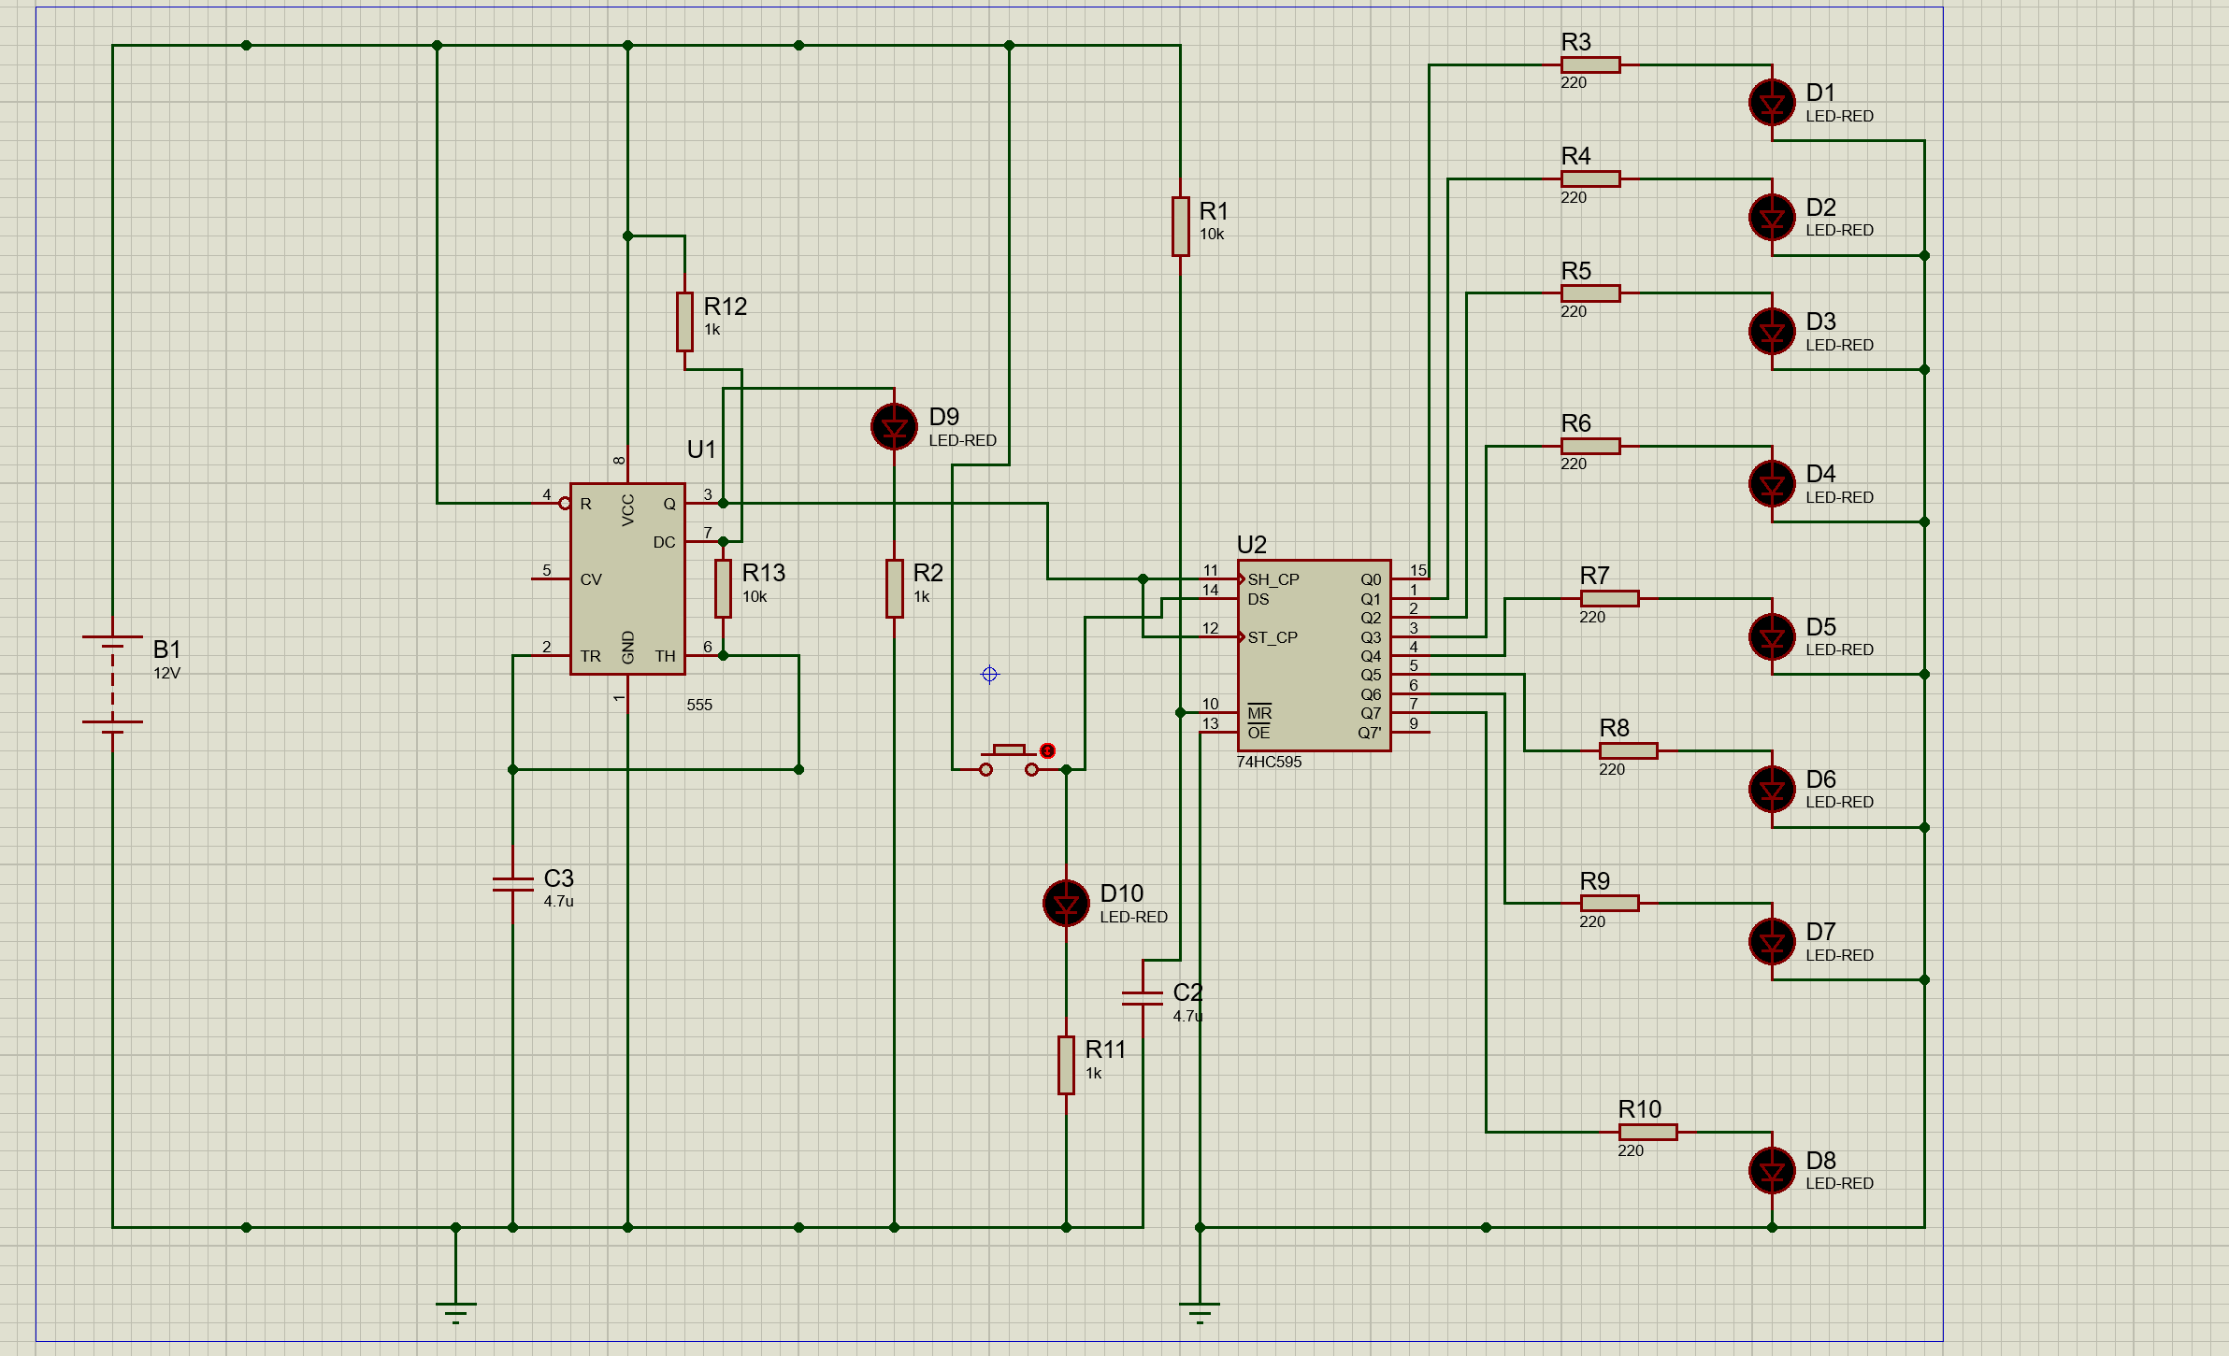

6. Testing and Evaluation
Testing Procedure:
- Confirmed the 555 Timer's output waveform using an oscilloscope.
- Verified correct cascading of 74HC595 registers.
- Observed continuous flowing LED sequence.
- Adjusted the potentiometer to observe real-time changes in LED movement speed.
Evaluation Criteria:
- Stable and glitch-free operation.
- Seamless pattern recycling.
- Responsive speed control through potentiometer without circuit instability.
7. Results and Discussion
Key Observations:
- Successfully achieved smooth LED movement across 16 LEDs.
- Real-time speed adjustment significantly enhanced user control.
- Cascading maintained data integrity across two shift registers.
Advantages:
- Cost-effective hardware design.
- No microcontroller or programming skills required.
Challenges:
- Fine adjustment of speed required sensitive potentiometer tuning.
Suggestions for Improvement:
- Implement logic circuits for automatic pattern changes.
- Introduce a mechanism to reverse frill direction.

8. Conclusion and Future Work
Conclusion:
The Electronic Frills project successfully demonstrated the use of analog and digital components to create an interactive and extendable LED pattern system. By merging two shift registers with a 555 Timer and user-controllable speed adjustment, the project achieved its educational and functional objectives.
Future Work:
- Expanding further by adding more cascaded registers for a larger number of LEDs.
- Implementing bi-directional LED shifting.
- Adding pre-programmed frill patterns without a microcontroller using simple logic gates.

9. References
1. Wikipedia - 555 Timer and 74HC595 ICs
2. YouTube Electronics Tutorials
3. Proteus Design Suite - Simulation and Testing

